Start up for Virtual Medical course organization

1. **Target group**

The service is concentrated on students at medical university.

1. **Product type**

Academic courses lasting whole period of studying.

1. **Product features**

Virtual medical course gives a chance to medical students to practice skills which hard to proceed at hospitals. This course’s equipment are virtual rooms and helmet. It focused in practicing surgeon and making decisions in critical environment and there is an opportunity to make operations that were done in real life. To that we collect notes about real surgeons from hospitals. Our principia is based on “Make it stick” book where it is written that studying is not reading and passing exam, it is when you can use your conceptual knowledge at critical environment while making decision.

1. **Brand**

Brand Name is Mreality. Colour of logo is blue and green(trust and peacful).

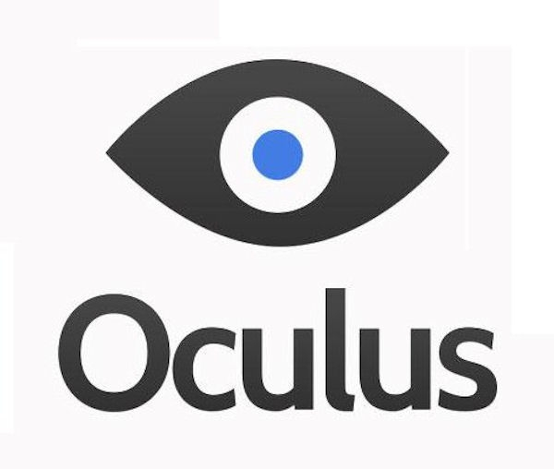

*Picture 1.* ***M****reality logo*

5.**Reason why in can be useful**.

As we know students from medical universities have their internship each year of their studying but it is true that they do not practice different hard tasks such as operation procedure or recognizing diseases, which are essential in their future job. Of course who would dive a responsibility to people who do not finish studying but how would they practice in order to be ready in the future?